[[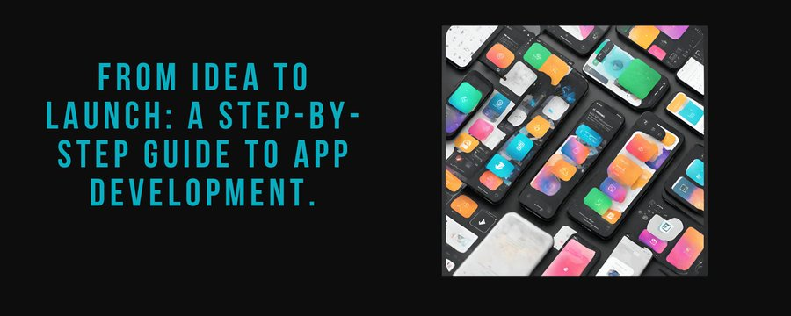](https://twitter.com/kasselsoft/article/1776797581135303040/media/1776787925356761088)](https://twitter.com/kasselsoft/article/1776797581135303040/media/1776787925356761088)

**From Idea to Launch: A Step-by-Step Guide to App Development**

So, you've got a brilliant idea for an app, but how do you turn that idea into a successful reality? In this guide, we'll take you through the essential steps of app development, from validating your idea to launching and marketing your app. Let's dive in!

[[](https://twitter.com/kasselsoft/article/1776797581135303040/media/1776789776059813888)](https://twitter.com/kasselsoft/article/1776797581135303040/media/1776789776059813888)

**Idea Validation and Market Research:**

Finding Your Niche Before you start pouring hours of time and energy into developing your app, it's crucial to validate your idea and conduct thorough market research. Ask yourself: Is there a demand for your app? Who are your target users? What problem does your app solve? By gathering feedback from potential users and analyzing market trends, you can ensure that your app is meeting a real need and has the potential for success. Once you've validated your idea, it's time to dive deeper into market research. Take a look at your competitors - what are they doing well, and where are there gaps in the market that your app can fill? By understanding your competition and the needs of your target audience, you can position your app for success from the get-go.

[[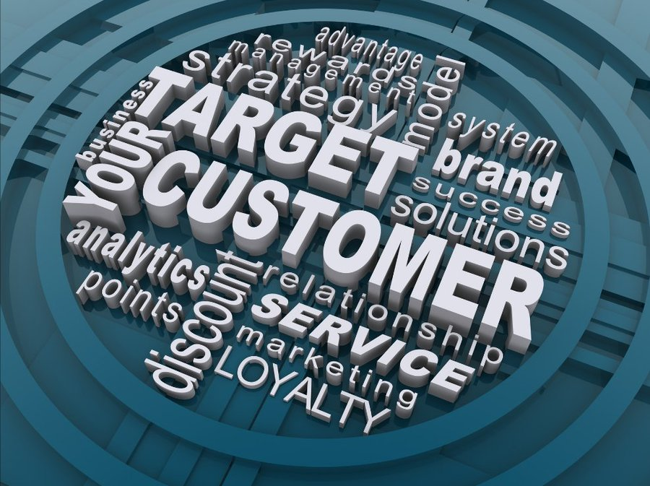](https://twitter.com/kasselsoft/article/1776797581135303040/media/1776791278602080256)](https://twitter.com/kasselsoft/article/1776797581135303040/media/1776791278602080256)

**Planning and Wireframing:**

Mapping Out Your Blueprint With your idea validated and your market research complete, it's time to start planning and wireframing your app. This step is all about mapping out the blueprint for your app's design and functionality. Start by outlining the key features and functionalities you want to include in your app, then create wireframes to visualize how these elements will come together. Wireframing is like sketching out the skeleton of your app - it helps you to see the overall structure and layout without getting bogged down in design details. Focus on creating a clear user flow and intuitive navigation system, keeping in mind the needs and preferences of your target audience. The goal here is to create a solid foundation for your app that will guide you through the development process.

[[](https://twitter.com/kasselsoft/article/1776797581135303040/media/1776792739566223360)](https://twitter.com/kasselsoft/article/1776797581135303040/media/1776792739566223360)

**Development and Testing:**

Bringing Your App to Life Now comes the fun part - development and testing! With your plan and wireframes in hand, it's time to start coding and building your app. Whether you're a seasoned developer or a newbie just getting started, the key is to break down your app's features into manageable chunks and tackle them one at a time. Once your app is built, it's crucial to put it through rigorous testing to ensure it's ready for prime time. Test for functionality, usability, and performance, and enlist the help of friends, family, and beta testers to uncover any bugs or glitches you may have missed. Remember, the goal here is to create a seamless and enjoyable user experience, so don't cut corners when it comes to testing.

[[](https://twitter.com/kasselsoft/article/1776797581135303040/media/1776793459086516224)](https://twitter.com/kasselsoft/article/1776797581135303040/media/1776793459086516224)

**Launch and Marketing Strategies:**

Launching your app is a thrilling moment, but it's just the first step on the path to success. To ensure a smooth liftoff and sustained user growth, you need a strategic launch and marketing plan. Pre-launch efforts like social media teasers and press outreach can build anticipation, while a well-optimized app store listing with captivating visuals becomes your digital storefront. The launch itself should be a coordinated effort across app stores to maximize reach. But your mission doesn't end there! Actively listen to user feedback, consistently create valuable content, and leverage influencer partnerships to keep your app at the forefront of users' minds. Finally, data analysis is your guiding light, helping you refine your strategy and ensure your app continues to soar in the competitive mobile landscape.

[[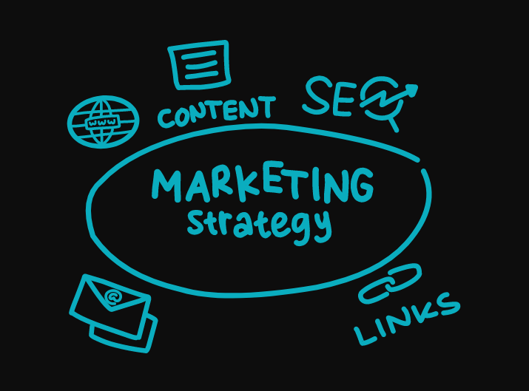](https://twitter.com/kasselsoft/article/1776797581135303040/media/1776795850829627392)](https://twitter.com/kasselsoft/article/1776797581135303040/media/1776795850829627392)

Launching your app is just the beginning of your journey towards success. With our help, you can turn your dreams into reality. At Kassel Company, we have a team of experts dedicated to creating high-quality apps that stand out in the competitive market. But that's not all - we go above and beyond to ensure your app gets the attention it deserves. Before your app even hits the market, we'll work with you to create a buzz with pre-launch marketing efforts. From teaser campaigns to engaging social media posts and press releases, we'll make sure your app gets noticed. Once your app is live, our marketing strategies kick into high gear. We'll optimize your app for app stores, craft compelling social media campaigns, establish influencer partnerships, and run targeted email campaigns. Our goal is simple: to reach your target audience wherever they are and convince them to download and use your app. But our services don't stop there. We offer free business consultations to help you understand the market and identify opportunities for growth. Plus, our digital marketing experts will work with you to develop a customized strategy tailored to your app's unique needs. So why wait? Take your app to the next level with Kassel Company. Call us now at +962 79003 9555 or email us at kasselsoft@kasselsoft.com to get started. And don't forget to visit our website at [www.kasselsoft.com](http://www.kasselsoft.com)

for more information. Your app's success starts here!